

VISUAL ARTS STAGE 3 SAMPLE EXAMINATION

Section 7 of the New WACE Manual: General Information 2006–2009 outlines the policy on WACE examinations.

Further information about the WACE Examinations policy can be accessed from the Curriculum Council website at http://newwace.curriculum.wa.edu.au/pages/about_wace_manual.asp.

The purpose for providing a sample examination is to provide teachers with an example of how the course will be examined. Further finetuning will be made to this sample in 2008 by the examination panel following consultation with teachers, measurement specialists and advice from the Assessment, Review and Moderation (ARM) panel.

0000.doc




Western Australian Certificate of Education, Sample External Examination

Question/Answer Booklet

VISUAL ARTS
Please place your student identification label in this box
WRITTEN PAPER
STAGE 3

Student Number: In figures

In words

Time allowed for this paper
Reading time before commencing work: Ten minutes
Working time for paper: Two hours and thirty minutes

Materials required/recommended for this paper
To be provided by the supervisor
Question Booklet
Answer Booklet
Illustration Booklet

To be provided by the candidate
Standard items: Pens, pencils, eraser or correction fluid, ruler, highlighter

Important note to candidates
No other items may be taken into the examination room. It is your responsibility to ensure that you do not have any unauthorized notes or other items of a non-personal nature in the examination room. If you have any unauthorised material with you, hand it to the supervisor before reading any further.

Structure of this paper

Section of exam | Suggested working time | Number of questions | Number of questions to be attempted | Marks available
Section One:  Comparative Image Analysis | 60 minutes | 1 | 1 | 40
Section Two:  Image Analysis | 30 minutes | 1 | 1 | 20
Section Three:  Case Study | 60 minutes | 1 | 1 | 40
 |  |  | [Total marks] | 100 (100%)

Instructions to candidates
- The rules for the conduct of the Western Australian external examinations are detailed in the TEE/WACE Handbook. Sitting this examination implies that you agree to abide by these rules.

- Write your answers in the Answer Booklet.
A blue or black ball-point or ink pen should be used.

SECTION ONE: COMPARATIVE IMAGE ANALYSIS

This section contains ONE (1) question. You must answer this question.

Allow approximately 60 minutes to answer this section [40 marks].

Question 1
In answering this question candidates must apply their knowledge and understanding of the four critical analysis Frames.

Refer to Image A and Image B in Illustration Booklet to answer this question.

Study the two images. Image A, a painting by the artist Ingres, was created in the 19th century in the neo-classical tradition. Image B was created by a group of contemporary feminist artists, who maintain their anonymity by wearing gorilla masks.

Compare Image A and Image B. Discuss how both artworks present the female body and outline how they communicate issues related to gender.

END OF SECTION ONE
SECTION TWO: IMAGE ANALYSIS

This section has ONE (1) question. You must answer this question.

Allow approximately 30 minutes to answer this section [20 marks].

Question 2
In answering this question candidates must apply their knowledge and understanding of the four critical analysis Frames.

Select ONE of the following images: Image C, Image D, Image E, Image F, Image G or Image H from the Illustration Booklet and answer this question.

Discuss the meaning conveyed by the image you have chosen giving consideration to the context in which it was produced. Identify and explain the key elements and techniques used by the artist to communicate meaning in the artwork.

END OF SECTION TWO

SECTION THREE: CASE STUDIES

This section has ONE (1) question with two parts. You must answer ALL parts of this question.

Allow approximately 60 minutes to answer this section [40 marks].

Question 3
In answering this question you must refer to at least ONE case study investigation you have completed this year in either an Australian or an international context.

Art is shaped by the society in which it is both created and experienced.

- With reference to one or more of your case studies discuss how the artist or artists you investigated were influenced and shaped by the society of their times. Refer to specific artworks in your response.

- Critically discuss how at least one or more of your case studies has influenced your work.

ACKNOWLEDGEMENTS

SECTION ONE

Image A Ingres, Jean Auguste Dominique. (1814). La grand odalisque.

Image B Guerrilla Girls. (1989). The advantages of being a woman artist.
Guerrilla Girls. (1989; 1995). Do women have to be naked to get into the Met. Museum?
Guerrilla Girls. (1989; 1995). Bus companies are more enlightened than NYC art galleries.
Guerrilla Girls. (1990; 1995). Guerrilla Girls’ pop quiz.
© Guerrilla Girls. Courtesy www.guerrillagirls.com

SECTION TWO

Image C Taylor, Howard. (1971). Tree forms.

Image D Mori, Mariko. (1995). Birth of a star.

Image E Story, Holly. (2000). Rose banskia [Photo, silkscreen and hand embroidery on cotton twill, h2200cm x w1700cm].

Image F Onus, Lin. (1991). Fruit bats.
© Lin Onus. Licensed by VISCOPY, Australia, 2007.

Image G Kruger, Barbara. (1984). Untitled (Buy me I'll change your life) [Photograph, 72in x 48in (183cm x 122cm)].
Courtesy: Mary Boone Gallery, New York

Image H Koons, Jeff. (1992). Puppy.

ILLUSTRATION BOOKLET

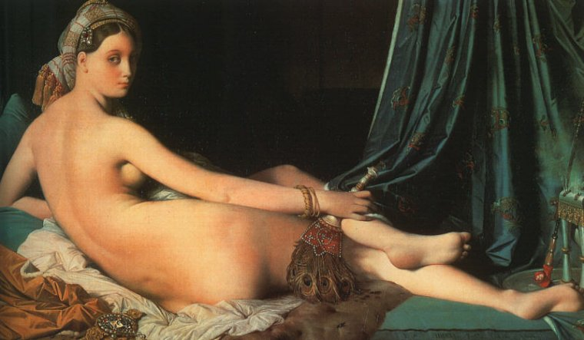

IMAGE A
Ingres, Jean Auguste Dominique. (1814). La grand odalisque.

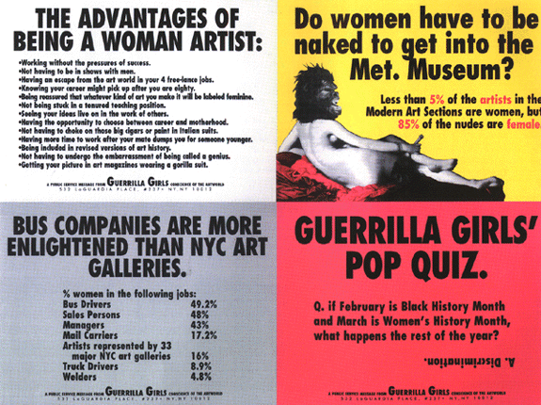

IMAGE B
Guerrilla Girls. (1989). The advantages of being a woman artist.
Guerrilla Girls. (1989; 1995). Do women have to be naked to get into the Met. Museum?
Guerrilla Girls. (1989; 1995). Bus companies are more enlightened than NYC art galleries.
Guerrilla Girls. (1990; 1995). Guerrilla Girls’ pop quiz.
ILLUSTRATION BOOKLET

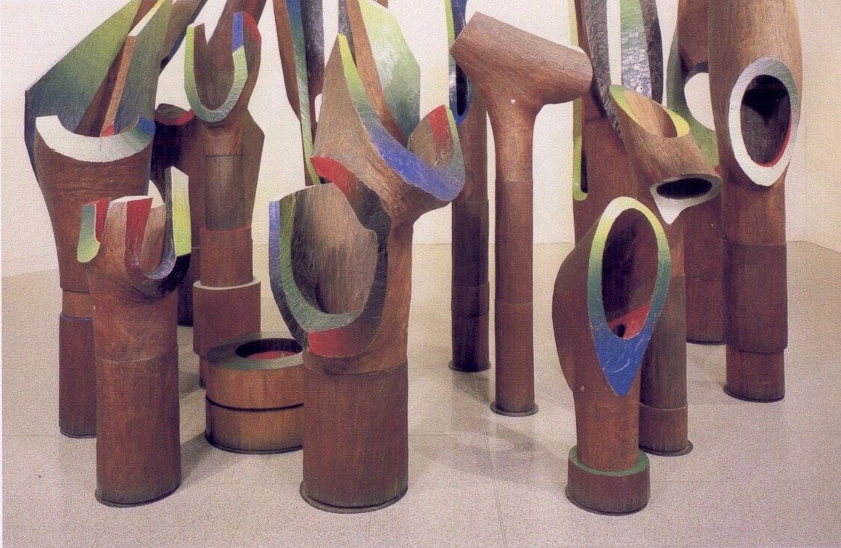

IMAGE C
Taylor, Howard. (1971). Tree forms.

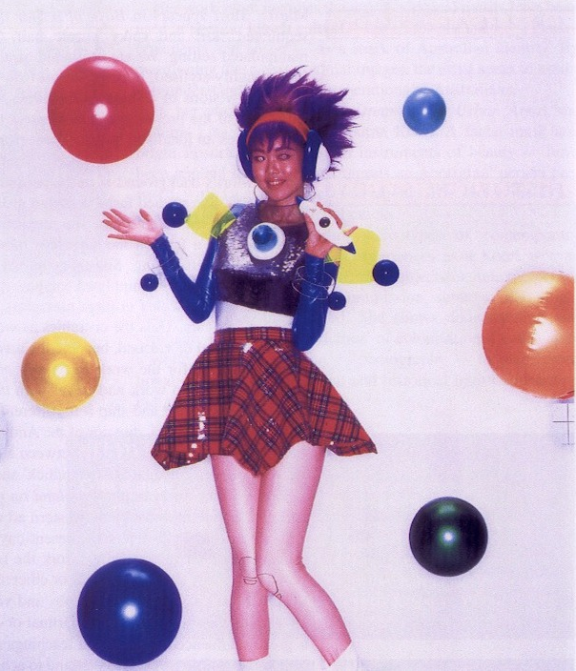

IMAGE D
Mori, Mariko. (1995). Birth of a star.

ILLUSTRATION BOOKLET

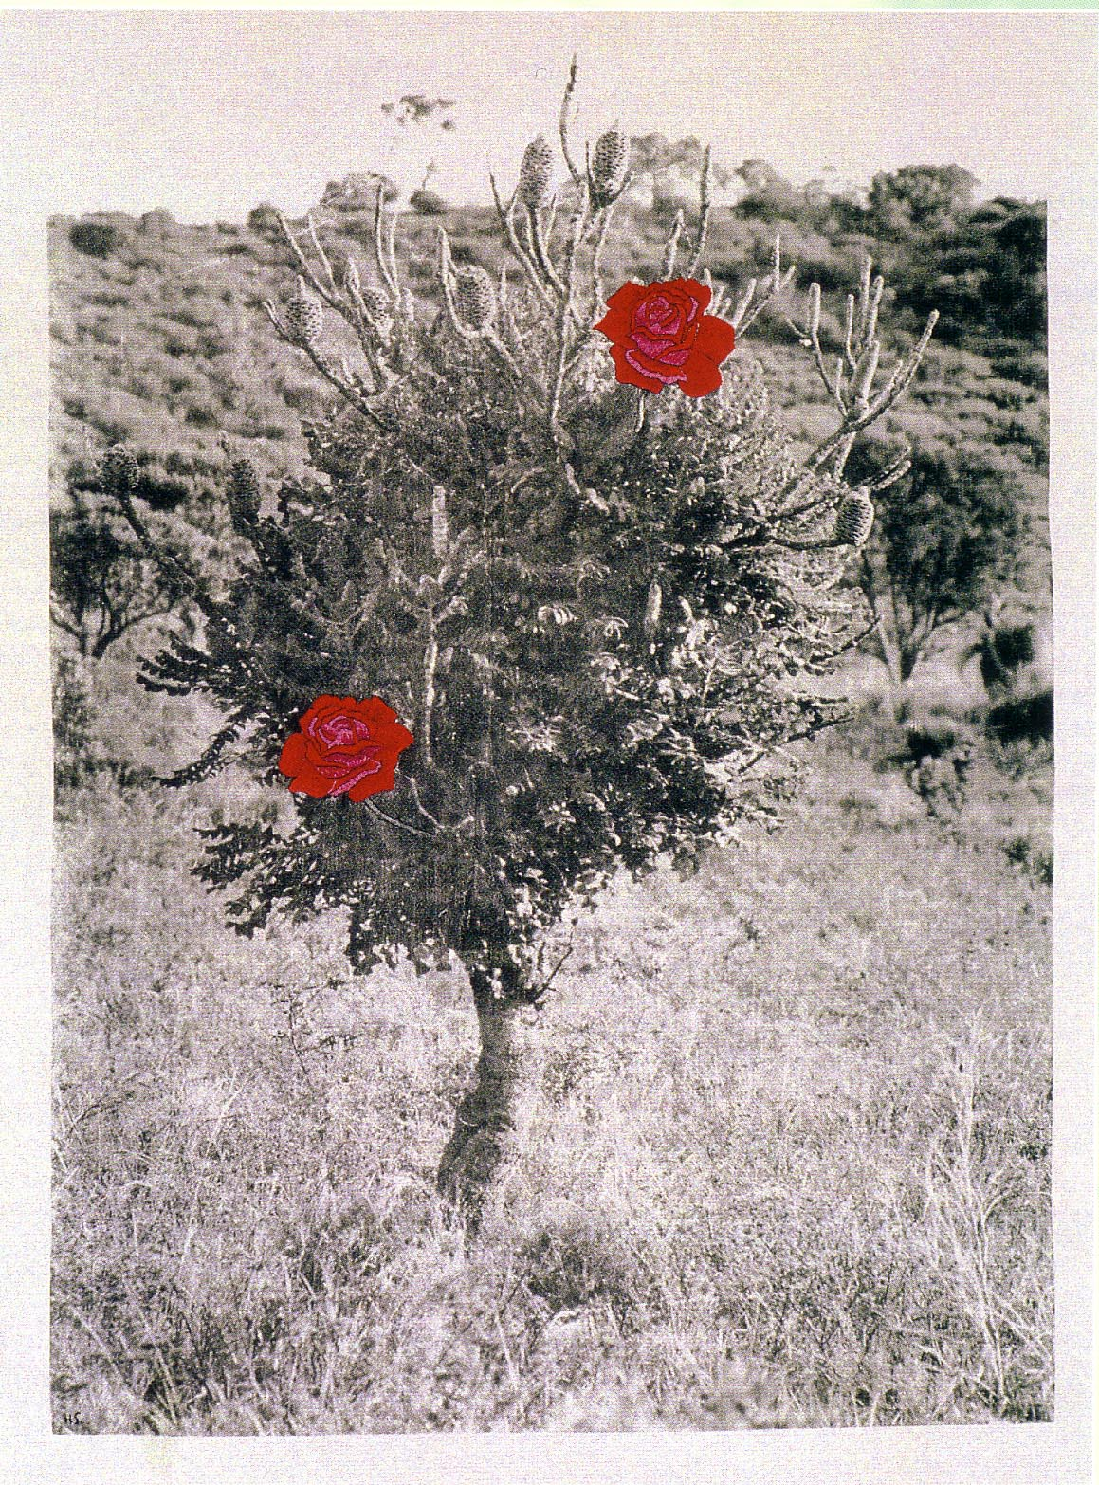

IMAGE E
Story, Holly. (2000). Rose banskia
[Photo, silkscreen and hand embroidery on cotton twill, h2200cm x w1700cm]

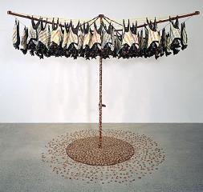

IMAGE F
Onus, Lin. (1991). Fruit bats.
© Lin Onus. Licensed by VISCOPY, Australia, 2007.

ILLUSTRATION BOOKLET

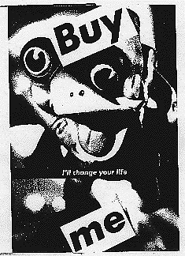

IMAGE G
Kruger, Barbara. (1984). Untitled (Buy me I'll change your life)
[Photograph, 72in x 48in (183cm x 122cm)]
Courtesy: Mary Boone Gallery, New York

For copyright reasons this image cannot be reproduced in the online version of this document but may be viewed at http://de.wikipedia.org/wiki/Bild:Bilbao_Jeff_Koons_Puppy.jpg
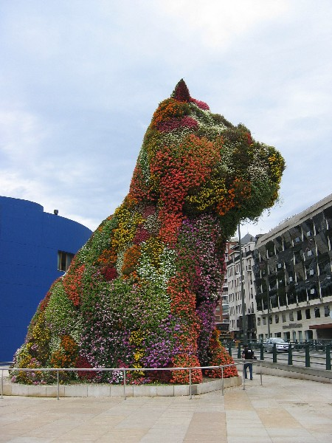

IMAGE H
Koons, Jeff. (1992). Puppy.

